EXPERIMENT 1A
#include <stdio.h>
#include <unistd.h>
#include <fcntl.h>
int main(){
int fd;
char buffer[50];
/* open() – create and open a file */
fd = open("sample.txt", O_CREAT | O_RDWR, 0644);
if (fd < 0)
{
printf("File opening failed\n");
return 1;
}
/* write() – write data into file */
write(fd, "Hello OS Lab", 12);
/* move file pointer to beginning */
lseek(fd, 0, SEEK_SET);
/* read() – read data from file */
read(fd, buffer, 12);
/* display data */
printf("Data read from file: %s\n", buffer);
/* close() – close the file */
close(fd);
return 0;
}
OUTPUT:
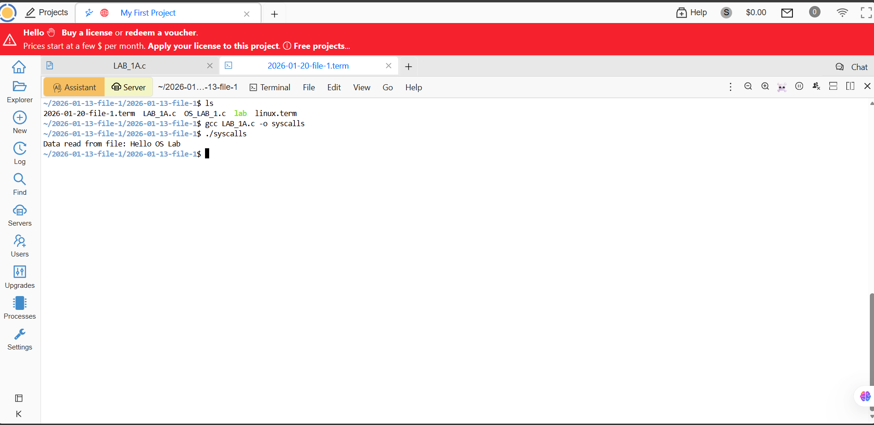

EXPERIMENT 1B
#include <stdio.h>
#include <dirent.h>
int main(){
DIR *d;
struct dirent *entry;
/* open current directory */
d = opendir(".");
if (d == NULL)
{
printf("Directory cannot be opened\n");
return 1;
}
/* read directory entries */
printf("Directory contents:\n");
while ((entry = readdir(d)) != NULL)
{
printf("%s\n", entry->d_name);
}
/* close directory */
closedir(d);
return 0;
}

OUTPUT:
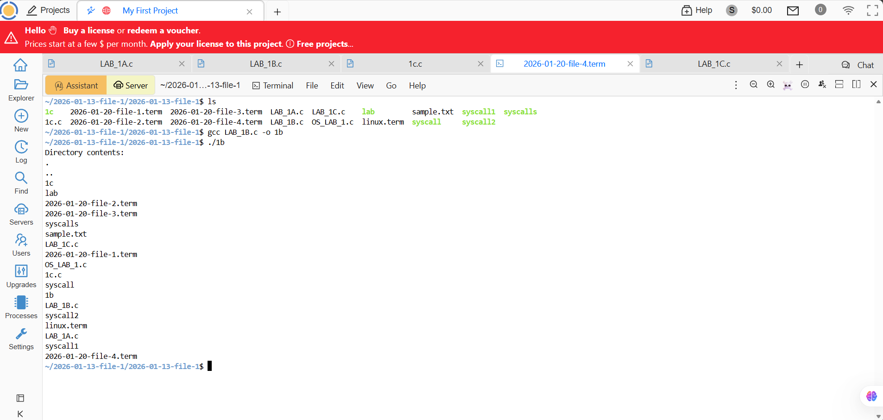

EXPERIMENT 1C
#include<stdio.h>
#include<unistd.h>
#include<sys/types.h>
void main()
{
printf("Before declaring FORK.");
printf("The value of PID is : ");
printf("%d",getpid());
printf("The value of PPID is : ");
printf("%d",getppid());
pid_t pid=fork();//Used to create child process
if(pid==0)//Child Process
{
printf("After declaring FORK.");
printf("The value of PID is zero.");
printf("The value of PID is : ");
printf("%d",getpid());
printf("The value of PPID is : ");
printf("%d",getppid());
}
else if(pid>0)//Parent Process
{
printf("After declaring FORK.");
printf("The value of PID is greater than zero.");
printf("The value of PID is : ");
printf("%d",getpid());
printf("The value of PPID is : ");
printf("%d",getppid());
}
else//Error
{
printf("After declaring FORK.");
printf("The value of PID is less than zero.");
printf("The value of PID is : ");
printf("%d",getpid());
printf("The value of PPID is : ");
printf("%d",getppid());
}
}

OUTPUT:
